ADRIAN TURION |  | Avenue de Sainte-Clotilde 9  1205 Geneva, Switzerland | 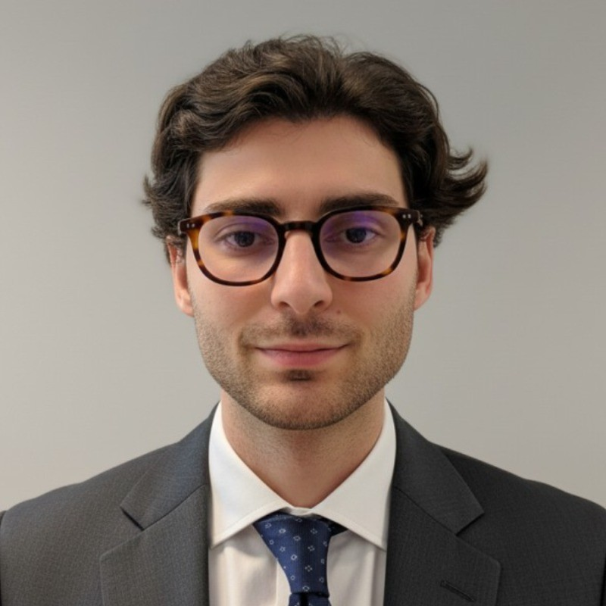
turionadrian@gmail.com | Swiss | 10.11.2000 |  | +41 77 262 37 96
INTRODUCTION
M&A analyst with track record in fast-paced, client-facing environments. Skilled in market analysis, financial modeling, and information processing across 10+ mandates. Demonstrated commercial aptitude through AIESEC (CHF 60K revenue) and entrepreneurial ventures. Seeking to apply hard-working mindset to Lightship Academy's ship broker training in dry-bulk maritime freight.
WORK EXPERIENCE
Auraïa Capital Advisory – Small & Mid Cap Cross-border M&A Boutique  Mergers & Acquisitions Analyst (Converted internship into full-time position) |  | Geneva, Switzerland  Aug 2024 – Current
- Executed deal processes in 3-person team across 7 mandates (sell-side, buy-side, debt advisory), managing client relationships, coordinating advisors, and negotiating terms for EUR 5M-50M transactions in healthcare, tech, and life sciences
- Built financial models (LBO, DCF, comps, precedent transactions) and conducted market research to identify strategic buyers for cross-border deals spanning Europe, US, and Asia, processing information for client presentations and Board meetings
- Led marketing materials production, maintained buyer universes, and coordinated data rooms across concurrent mandates, demonstrating multitasking and collaborative approach while training 2 interns in M&A practices

RC Group – Currently under LBO with Crédit Mutuel Equity  Mergers & Acquisitions Intern |  | Paris, France  Feb 2024 – Aug 2024
- Worked with CEO on evaluating acquisition targets in France and Belgium, preparing investment memos with market analysis for 3 potential acquisitions (EUR 10M-30M), and conducted due diligence to assess synergies and value creation opportunities

Europ Assistance – Subsidiary of Generali Insurance  Financial Analyst Intern |  | Geneva, Switzerland  Apr 2023 – Aug 2023
- Supported CFO on FP&A for CHF 50M+ subsidiary, building automated dashboards in Excel and PowerBI to track KPIs and perform variance analysis, and assisted in budget planning and forecasting for 5 business units, enhancing information processing

LEADERSHIP
- Finalist in McKinsey business case, presenting data-driven model to forecast market events using statistical arbitrage, showcasing analytical rigor and problem-solving under pressure
- Led AIESEC's post-COVID financial recovery by sourcing corporate leads and negotiating partnerships, closing 3 deals generating CHF 60K annual revenue and demonstrating resilience and commercial drive
- Founded Screeny.ai, an AI software for investment banks to identify acquirers, leading full-stack development and B2B sales outreach, with tool adopted by 3 firms reducing buyer search time by 90%
EDUCATION
HEC Lausanne  Master of Science in Finance |  | Lausanne, Switzerland  2021 – 2024
- Cumulative GPA: 5.2/6.0 (Top 15% of the class cohort)
- Exchange programs at Waseda University (Tokyo, Japan) and Maastricht University (Maastricht, Netherlands)
- Relevant Coursework: Derivatives, Investment and Portfolio Management, Corporate Governance and M&A
- Thesis Topic: Synergies Analysis of the Merger between American Airlines & US Airways

Bachelor of Science in Management |  | 2018 – 2021
- Cumulative GPA: 4.7/6.0

Scientific Baccalaureate with Highest Honors (16.6/20) |  | Aix-en-Provence, France
ADDITIONAL INFORMATION
Languages:  Computer:  Interests:  References: | French (Native, C2), Spanish (Native, C2), English (Fluent, C1), German (Business proficient, B2-C1)  Financial modeling | Market analysis | Client management | Data processing | Negotiation  Geopolitics, Badminton (Provence regional finalist), Gym, Real use cases of Artificial Intelligence  Guillaume Arnaldez – Ex-Director at Auraïa Capital Advisory, guillaume.arnaldez@auraia.ch  Sacha Caravatti – CFO at Europ Assistance Switzerland, scaravatti@europ-assistance.ch

